IOB.Connect™ P20 Gateway

Installation Guide for Scotsman Prodigy Cuber Ice Machines

Document Revision
Version: 2.0
Date: 6/23/2026
Prepared By: IOB, Inc.

Overview
The IOB.Connect™ P20 Gateway provides real-time monitoring, remote diagnostics, two-way communication, and operational insights for Scotsman Prodigy Cuber Ice Machines [Scotsman].
This guide provides step-by-step instructions for installing and activating the IOB P20 Remote Monitoring Gateway [Gateway].

Package Contents
Verify that the following components are included:
- P20 Gateway
- Cellular Antenna
- Serial Communication Cable
- Rubber Grommet
- DC Power Supply
Installer-Materials (not provided):
- Heavy-duty double-sided mounting tape or
- Self-tapping mounting screws
- Screwdrivers and basic hand tools
- Cable ties

Safety Information
Before beginning installation:
- Disconnect power to the Scotsman ice machine.
- Follow all applicable electrical safety procedures.
- Do not install equipment while power is energized.

Installation Requirements
Compatible Equipment:
- Scotsman Prodigy Cuber Series Ice Machines
Installation Requirements:
- Standard electrical outlet available for P20 power supply
- Adequate cellular signal strength
- Access to machine controller compartment

Step 1 – Power Down Equipment
- Power OFF the ice machine.
- Disconnect power from the machine.
- Verify all power has been removed before proceeding.

Step 2 – Remove Machine Panels
- Remove the front access panel.
- Remove the top panel (recommended), for easier accesses to Scotsman Controller.
- Retain all hardware for reinstallation.
Note:
Panel locations and fasteners may vary by model.

Step 3 – Install Serial Communication Cable
Locate the cable access opening at the rear of the machine.
- On the back of the Scotsman, remove the bottom solid white grommet.
- Insert the supplied rubber grommet into the opening.
- Route the serial cable through the grommet. The BLACK end, with 6-pins.
- Open the Scotsman Controller compartment.
- Route the cable neatly to the controller board.
- Secure cable routing using cable ties.
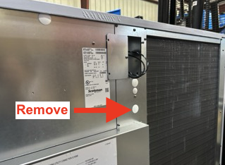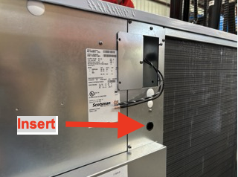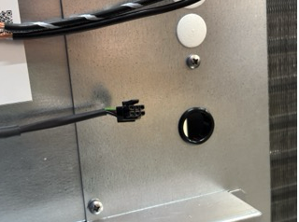

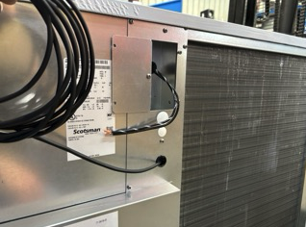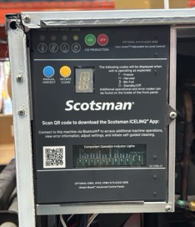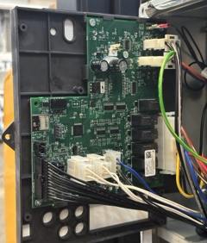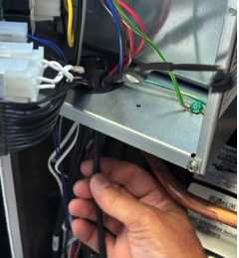

Step 4 – Connect to Scotsman Controller
- Locate the communication connector on the Scotsman controller board.
- Connect the BLACK 6-pin connector.
- Verify the connector is fully seated.
Important:
The connector is keyed and can only be installed in one orientation.
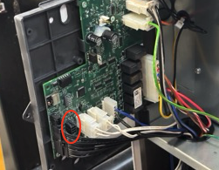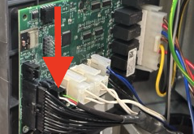

Step 5 – Reinstall Machine Panels
- Close the controller compartment.
- Reinstall all removed panels.
- Verify that no cables are pinched or exposed.

Step 6 – Record Gateway Information
Before mounting the gateway:
Record the following information:
Agent ID: ____________________
IMEI Number: ____________________
Take a photograph of the gateway label for future reference.
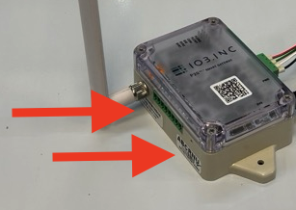

Step 7 – Mount the Gateway
Select a mounting location:
- Protected from water exposure
- Away from moving components
- Accessible for service
- Provides adequate cellular signal
Mount using:
Option A:
Heavy-duty double-sided tape
Option B:
Self-tapping screws
Ensure mounting surfaces are clean and dry before installation.

Step 8 – Connect Serial Cable to Gateway
- Connect the GREEN 4-pin connector to the gateway serial port.
- Ensure the connector is fully seated.
- Verify cable strain relief.
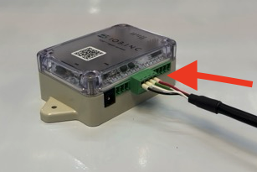

Step 9 – Install Cellular Antenna
- Attach antenna to the gateway.
- Hand tighten only. Do NOT overtighten.
- Position antenna vertically.
For best cellular performance:
- Keep antenna unobstructed.
- Avoid metal obstructions where possible.
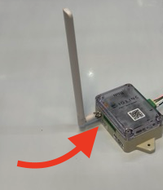

Step 10 – Connect Power
- Insert the DC power connector into the gateway.
- Connect power supply to an AC outlet.
Gateway Startup:
- Three red LEDs indicate power is present.
- Cellular communication LED will flash during network registration.
- LED will become solid once connected.
Expected connection time:
1–3 minutes.
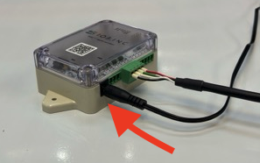

Step 11 – Power Up Ice Machine
- Restore power to the ice machine.
- Verify normal machine operation.

Step 12 – Activate Device
Navigate to: https://lightning.hellothing.com
Activation Information Required:
- Agent ID
- IMEI Number
If you are a new user:
- Create an account.
- Register the gateway.
- Select a subscription plan (monthly / annual).
- Verify successful communication.

Installation Verification Checklist
☐ Gateway mounted securely
☐ Antenna installed
☐ Serial cable connected
☐ Power connected
☐ LEDs indicate cellular connectivity
☐ Ice machine operational
☐ Device activated
☐ Machine Data visible on portal

Troubleshooting

No Power LEDs
Possible Causes:
- Power supply disconnected
- Outlet not energized
- Defective power adapter
Actions:
- Verify outlet power
- Verify DC connection
- Replace power supply if necessary

Gateway Not Connecting to Cellular Network
Possible Causes:
- Poor signal strength
- Antenna disconnected
- SIM provisioning issue
Actions:
- Verify antenna connection
- Relocate antenna if necessary, (Optional Booster Antenna)
- Contact IOB Support

No Machine Data Visible
Possible Causes:
- Serial cable disconnected
- Incorrect controller connection
- Device not activated
Actions:
- Verify all cable connections
- Verify portal activation
- Restart gateway

Technical Support
For assistance, contact:
Email: Support@IOB.Inc
Please include:
- Agent ID
- IMEI Number
- Ice Machine Model Number
- Description of Issue
- Photos of Installation (if applicable)

Installation Record
Customer: _____________________
Location: _____________________
Machine Model: _____________________
Gateway Agent ID: _____________________
Gateway IMEI: _____________________
Installed By: _____________________
Installation Date: _____________________

